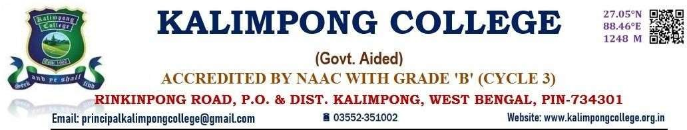

**DIAMOND JUBILEE CELEBRATION 2022**

**EXHIBITION AND MODEL DISPLAY**

**DEPARTMENT OF POLITICAL SCIENCE**

**KALIMPONG COLLEGE**

**DATE: 10. 11. 2022**

**Introduction**

The Department of Political Science for the very first time had taken the initiative to organize the Exhibition and Model Display programme on the eve of Diamond Jubilee with the intentions to engage the students of the department into some creative learning activities. Almost all the students have been assigning to make the models of different political concepts and theories. The Students created intricate models illustrating various political systems, institutions and the United Nation Organization. Through these interactive displays the students were successful to engage visitors from different schools and facilitate a deeper understanding of political concepts and processes.,

**Objective**

The Exhibition and Model display aimed to showcase the creative and analytical skills of students in the Subject matter. The event provides a platform for students to demonstrate their understanding of complex political concepts and theories through innovative and interactive displays,

**Outcomes:**

The event organized by the department of Political Science was a huge success achieving its objectives and exceeding expectations. Students demonstrated a deeper understanding of complex political concepts and theories through their display and presentations. The Exhibition encouraged the students to think creatively and develop innovative way to present and explain different political concepts. The exhibition also helps the students to develop essential teamwork skills, collaborating with their peers to design and present their models. Students improve their public speaking skills, presenting their work to a diverse audience. The Exhibition raised awareness about the importance of Political Science amongst the students. It has also worked as a medium of community engagement as many local schools, colleges and community group were invited to participate in the event and promote awareness and engagement.

\

